### Editing Existing Users

Using the search tools at the left of the screen, a search can be performed by user name, or by performing an advanced search (by typing the user’s first name, middle name, last name, or selecting their user group or role). Search results will appear to the right of the search tools.

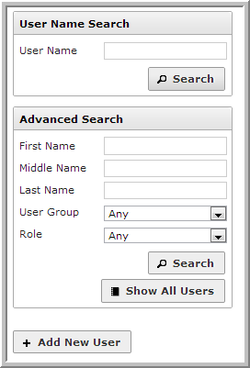

Searches that match exactly will take you directly the *Edit User* screen. Searches with more than one possible match will display a list of users. Click anywhere on the row containing the user to be taken to the *Edit User* screen.